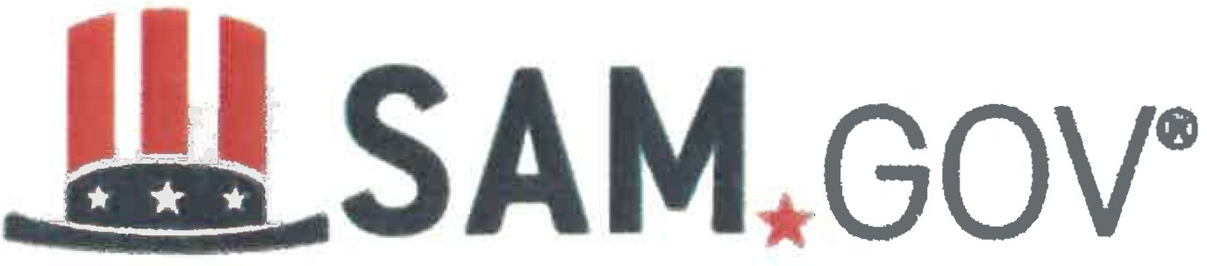

Quick Start Guide for Getting a Unique Entity ID in SAM.gov

In order to become a contractor with the City of Dearborn’s Home Rehabilitation Program, you must have a Unique Entity ID from SAM.gov.
This ID must be renewed each year.

You can get a Unique Entity ID (SAM) for your organization without having to complete a full entity registration. If you only conduct certain types of transactions, such as reporting as a sub-awardee, you may not need to complete an entity registration. Your entity may only need a Unique Entity ID (SAM).

If you want to only get a Unique Entity ID (SAM) and do not want to complete a full entity registration in SAM.gov, choose either A., B. or C. below that best describes your entity and read further on for those instructions:

- Your entity has a DUNS Number and is registered in SAM.gov

- Your entity has a DUNS number and is NOT registered in SAM.gov

- Your entity does not have a DUNS Number

- Your entity has a DUNS Number and is registered in SAM.gov

If you have an active or inactive registration in SAM.gov today, you’ve already been assigned a Unique Entity ID (SAM). It’s viewable on your entity registration record in SAM.gov.

- Your entity has a DUNS Number and is not registered in SAM.gov

If you currently have a DUNS Number, only need to get a Unique Entity ID (SAM), and do not want to complete a full entity registration in SAM.gov, follow these steps to get a Unique Entity ID (SAM):

- Go to SAM.gov and select “Sign In” from the upper right corner of the page. If you do not have a SAM.gov account, you will need to create one. SAM.gov uses Login.gov for authentication. Once you create your user credentials, you will return to SAM.gov to complete your profile.
- After you sign in, the system will navigate you to your Workspace. On the “Entity Management” widget, select the “Get Started” button.
- On the next page, enter information about your entity. All fields are required, unless marked as optional.
- On the next page, validate that the information provided is correct. If the information provided does not match your Dun & Bradstreet record exactly, you will be able to proceed. For assistance updating your Dan & Bradstreet record, please contact Dun & Bradstreet.

Deselect the check box near the bottom of the page if you want to restrict the public viewing of your entity information in SAM.gov. If you deselect the check box, only you and federal government users will be able to view your Unique Entity ID (SAM) record. Other entities and users of SAM.gov will not be able to view your Unique Entity ID (SAM) record. Then, select “Next.”

- On the next page, your entity is validated. You will be asked to certify that you are authorized to conduct transactions on behalf of your entity. Select the check box to certify, then select the “Request Unique Entity ID” button.

- On the last page, your Unique Entity ID (SAM) will be displayed and you can begin to use it for your entity.

- Your entity does not have a DUNS Number.
After April 4, 2022, the federal government will have no requirement for the DUNS Number. You can get a Unique Entity ID (SAM) for your entity on SAM.gov. The Unique Entity ID (SAM) is provided to entities who request to only get a Unique Entity ID (SAM) and to entities who complete an entity registration.

Sign in to your SAM.gov account and the system will navigate you to your Workspace. On the "Entity Management" widget, select the "Get Started" button to begin requesting your Unique Entity ID (SAM).

